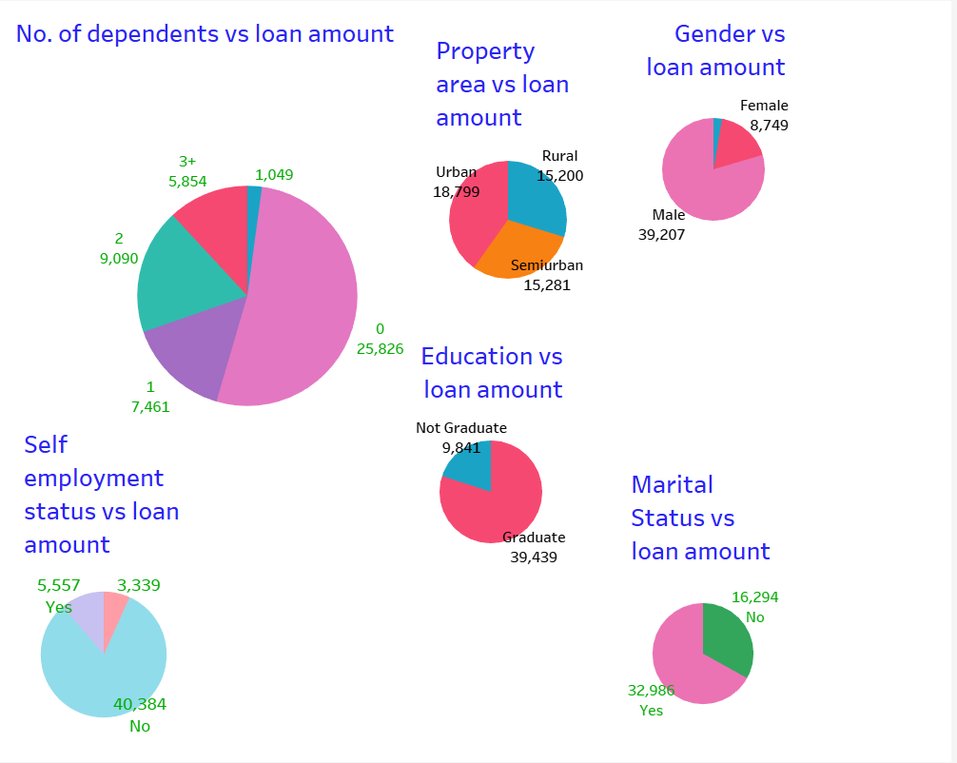

People with no dependants have applied for more loans

More males have applied for a loan than females

Urban area dwellers have applied the most but semi urban and rural settlers applicants don’t differ by a large quantity

Self-employed people have applied for 1/8th of the loans non self-employed people have applied for

Graduates are 3 times more likely to apply for a loan

More married people have applied for loans

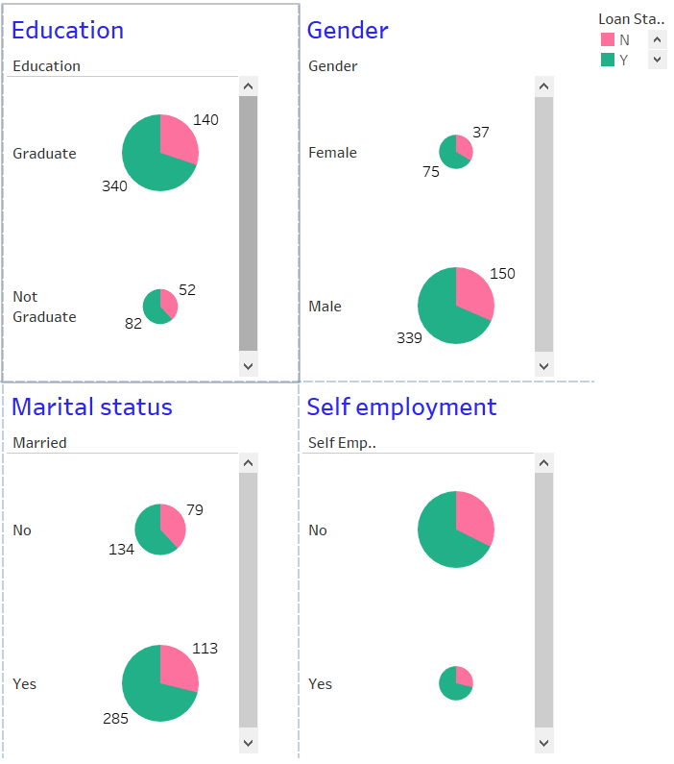

Graduates are more than twice as likely to get their loan approved

Both genders have an equal chance of getting their loan approved

Married couples have had more loans approved

Self-employment statuses don’t differ much when it comes to loan approval chances

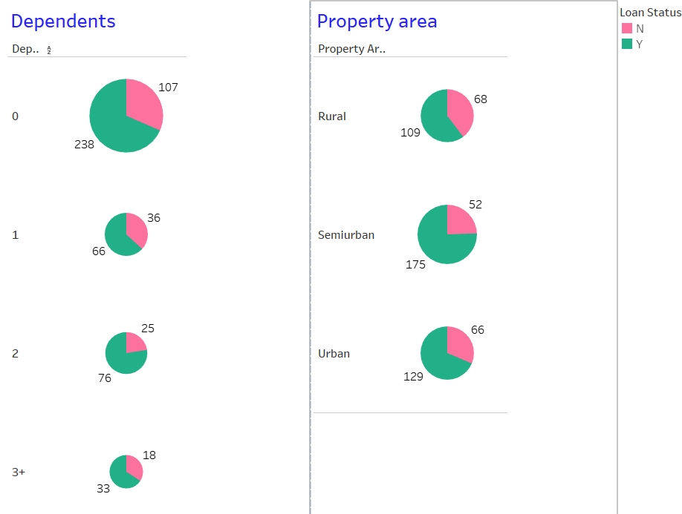

Loans applied by applicants with 2 dependents seem to be approved more

Loans applied by applicants with 1, 3+ have the same chance of being approved

Semi urban applicants have more loans approved than rural and urban applicants

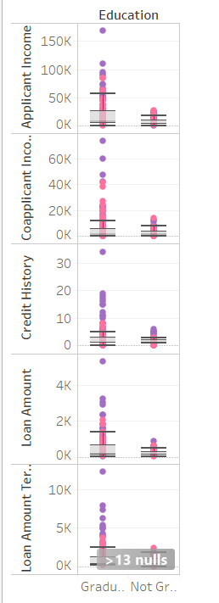

Outlier loans approved over upper whisker 57102 when comparing education and applicant income are mostly approved but rejected cases show a credit history of 0

Chances of getting a loan approved is very low if the applicant is not a graduate

Loans applied by graduates are most likely to be approved only when the applicant income exceeds the upper whisker value

Comparing education with co-applicant income

It is almost impossible to get a loan approved for non-graduates unless co-applicant income is higher than expected and credit history is 2

Only loans applied by graduates with a co-applicant whose income exceeds 40k have been approved

Comparing credit history with education

Only graduates whose sum(credit history)>10 have loans approved

Non graduate applicants have a slim chance of loan approval only if sum(credit history)>5

Comparing loan amount and education

Graduates whose loan amount exceeds 2k and/ credit history>12 have loans approved

Non-graduates have loans approved if their credit history exceeds 5

Comparing loan amount term and education

Graduates with credit history of 10 and more have loans approved

There isn’t enough data about non-graduate applicants to make an inference

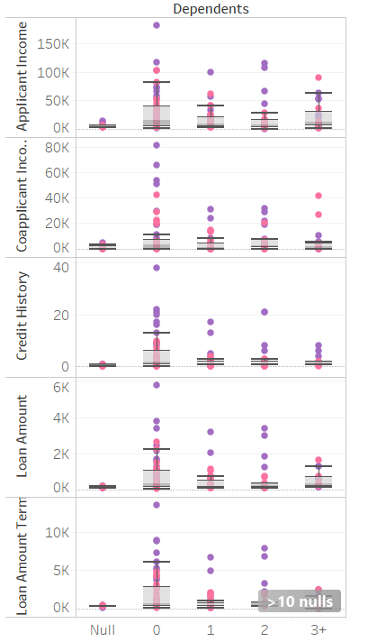

When comparing dependants and applicant income

Applicants with 2 dependants’ loans get approved when Applicant income exceeds upper whisker value

Applicants with lower credit history is likely to get disapproved even if applicant income is above average

Credit history is more important than applicant income irrespective of the number of dependants

When comparing co-applicant income with dependents

Having co-applicant with income above 50k ensures loan approval when there is just one dependent

Co-applicant income above 20k ensures loan approval when number of dependents is 2

Credit score especially matters when number of dependents is 2+

When comparing credit history and dependents

Applicants whose credit history is above average are most likely to have loans approved

When comparing loan amount with dependents

Only credit history of 8 and above helps

When comparing loan amount term and dependents

Applicants with 2+ dependents have more than 10 null values so inference might not be accurate

A rural female applicant’s loan has been approved over male counterparts with the same credit history of 8

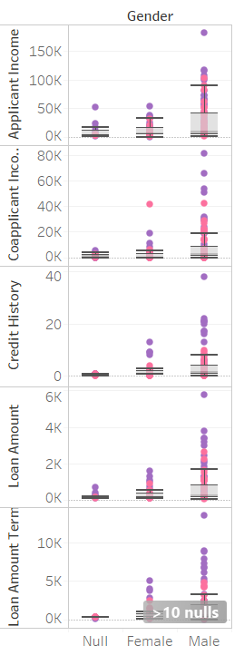

When comparing Gender with applicant income

Males with credit history above 20 are most likely to have their loans approved even if their income isn’t above expected range

Only credit history above 8 seems to guarantee the loan approval of a female applicant

When comparing co-applicant income with gender

A female with 3+ dependents and no discernable credit history has had her loan application rejected

Females with credit history above 9 have loans approved

When comparing loan amount with gender

A male with a credit history of 6 has had their load application approved only because of their income of 65k and their co-applicant’s income of 21k

Females with a credit history of 8 and above have their loans approved

When comparing loan amount term with gender

Above 10 null values might hinder accuracy of inferences

Credit history above 9 is required for the female loan approvals

Credit history above 16 is required for male applicant’s loan approvals

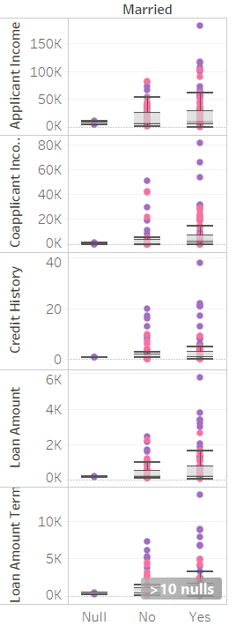

When comparing applicant income with marital status

A married person’s loan has been approved despite a credit history of 2 only because the incomes of both the applicant and the co-applicant are above average

A credit history of 17 and above is necessary for a married person’s loan approval

A credit history of 16 and above is necessary for an unmarried person’s loan approval having a higher income does not guarantee approval

When comparing co-applicant incomes with marital status

Only credit history of 21 and above guarantees loan approval in a married person’s case

Credit history of 8 is enough if co-applicants income exceeds expectations and applicant is an unmarried female

When comparing credit history with marital status

Credit history of 9 is enough if applicant is an unmarried female

An unmarried male with a credit score of 13 and above will be granted a loan

When comparing loan amount with marital status

A married male’s loan has been disapproved despite having no dependents and a credit history of 9 despite having a higher income than his counterparts (reason unknown)

An unmarried male with a credit history of 17 has been turned done for unknown reasons as similar applicants’ loans have been approved

When comparing loan amount term with marital status

10+ nulls hinder accuracy of inferences

Unmarried female with credit history of 8 has received loan approval but unmarried males require credit history of 13

Married male with a credit history of just 8 and 2 dependents has had his loan application approved over eligible counterparts (reason unknown)

Married males need a credit history of 21 and above for loan approval

Unmarried male applicant loans are approved if they have a credit history of 20 and above

When comparing applicant income with property area

Rural male applicant loans are approved if they have a credit history of 6 or 8 and dependents

It is very rare for a rural female to receive a loan and even applicants with higher credit histories and incomes have been turned down

Credit history of 20 and above matters in the case of semi-urban applicants

Somehow a semi-urban male with a credit history of just 2 has been given a loan

Applicant income matters more than credit history in the case of urban applicants

When comparing credit history with property area

Somehow a rural male with 2 dependents and a credit history of just 6 has gotten a loan approval

Other rural males need a credit history of 17 and above for a loan approval

A semi urban male with just 4 as credit history has gotten a loan over applicants with similar attributes but a higher credit history

Females seem to have an advantage over men in spite of occasionally having a credit history

When comparing loan amount with property area

In rural areas credit history doesn’t matter much

Semi urban females need just a credit history of 3 for a loan approval

Semi urban males with credit history of 13 and above and higher loan amounts get loans

Urban females need to have only a credit history of 9 to get a loan but males need only 5 (unknown reasons)

When comparing loan amount term with property area

10+ null values disrupt inferences

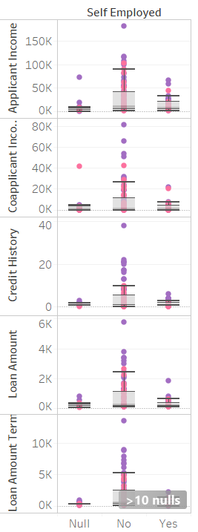

When comparing applicant income with self-employment status

Males with credit history of 20 and above get loan approvals when not self employed

Self-employed females need just a credit history of 2 and males need a credit history of 4 at least

When comparing co-applicant incomes with self-employment status

Applicant’s property area matters in the case of someone who’s not self employed

Credit history of at least 2 is necessary for someone who’s self-employed

When comparing credit history with self-employment status

Credit history of at least 9 is required for applicant who isn’t self-employed

Credit history of at least 3 is required for self-employed applicants

When comparing loan amount with self-employment status

Male applicants need a credit history of 16 and above for loan approval if they aren’t self-employed

Credit history doesn’t seem to matter in the case of a self-employed applicant

When comparing loan amount term with self-employment status

10+ null values hinder results

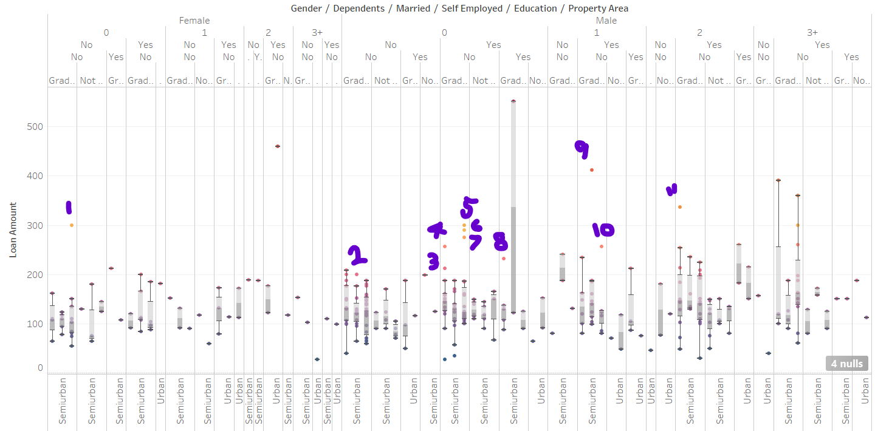

OUTLIER

1. Loan amount of 300 is unusual for an unmarried female graduate from an urban area who isn’t self-employed and has no dependents. The upper whisker is at 134 and max is 150
2. Loan amount of 200 is unusual for an unmarried graduate male from a semi-urban area with no dependents and isn’t self-employed. Upper whisker and max is at 176
3. A loan amount of 212 is unusual for a married graduate rural male who isn’t self-employed as 188 is the maximum loan amount
4. A loan amount of 257 is unusual for a married graduate rural male who isn’t self-employed as 188 is the maximum loan amount
5. A loan amount of 275 is unusual for a married graduate urban male who isn’t self-employed as 186 is the upper whisker loan amount
6. A loan amount of 290 is unusual for a married graduate urban male who isn’t self-employed as 186 is the upper whisker loan amount
7. A loan amount of 300 is unusual for a married graduate urban male who isn’t self-employed as 186 is the upper whisker loan amount
8. A loan amount of 232 is unusual for a married graduate rural male who is self-employed as 137 is the upper whisker loan amount
9. A loan amount of 412 is unusual for a married graduate semi-urban male with a dependent who isn’t self-employed as 187 is the upper whisker loan amount
10. A loan amount of 256 is unusual for a married graduate urban male with a dependent who isn’t self-employed as 126 is the upper whisker loan amount
11. A loan amount of 336 is unusual for a married graduate rural male with 2 dependents who isn’t self-employed as 254 is the upper whisker loan amount